Key Instant Recall Facts
Year 5 - Autumn term 1.
I know doubles and halves of all 2 digit numbers.

How to help at home: remember little and often is best! Practise doubling and halving as much as you can but in short bursts – maybe on the way to school or on a long car journey.
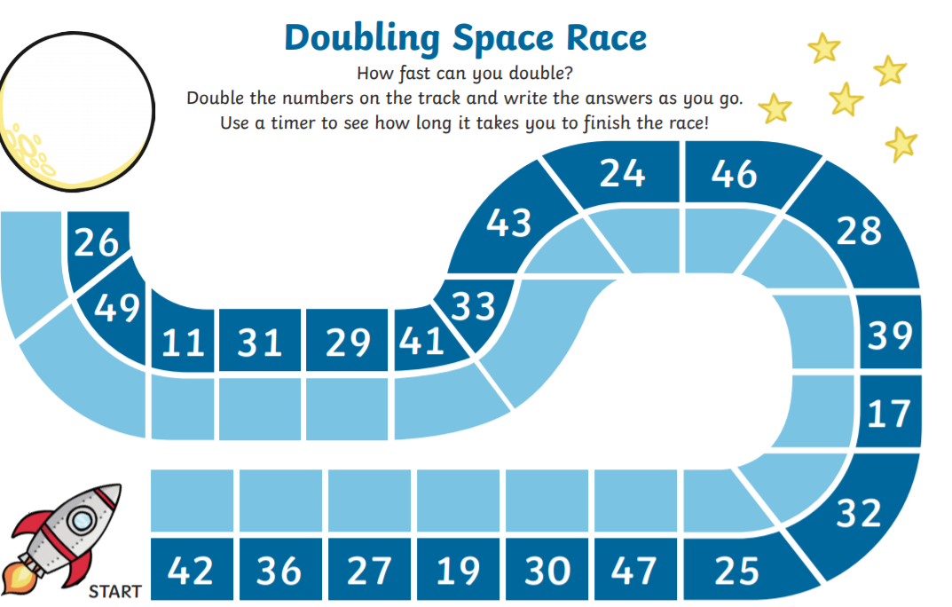

(you could make your own Space Race or ask a parent to help you)
Roll 2 dice or make some number cards. – can you double the number? Can you half the number?
double 7 is 14
Half of 22 is 11

