Key Instant Recall Facts
Year 1 - Autumn term 2.
I know all the number bonds to 10.
I can count in 10s to 100.

By the end of this term children should be able to count in 10s confidently to 100.
10, 20, 30, 40, 50, 60, 70, 80, 90, 100.

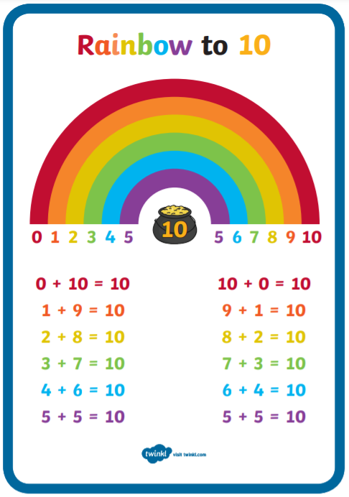
They should also be able to quickly recall number bonds to 10. Number bonds are 2 numbers that go together to make a number – in this case 10.

Ways to help at home.
Practise for a few minutes as often as you can. Little and often is best!
Once your child is becoming more confident you could give them one number and ask them “how many more to make 10”.
They could use cubes, pasta, teddies etc as well “you have 3 teddies in your bed… how many more make 10?”
Counting on fingers is also a great idea – for example put up 6 fingers and see if your child can count the fingers that are still down to find the number bond (6 + 4 = 10)
Remember – by the end of the term they should be able to recall these confidently and quickly without counting on their fingers.

