Wrens Class Medium Term Plan Summer 1

Communication and Language –

* Learn good listening skills
* Show an interest in stories
* Join in with repeated phrases
* Engage in conversation
* Learn new vocabulary to expand explanations

Personal, Social and Emotional Development –

* To share and take turns with friends.
* To manage their own feelings with support
* To manage personal hygiene
* The feeling of belonging and how we have a sense of belonging in our own
* Understand healthy eating and physical movement to support a healthy body.
* Focus on correct tooth brushing.

Physical Development –

* Follow Dough Disco for hand strength
* Threading, play dough, loose parts
* Learn how to zip up their coats
* To use tripod pencil grip confidently
* Scissor control
* Learn how to hold a knife and fork properly
* Parachute games
* Ball games
* Construction site outside
* Building dens

Literacy –

* Read Write Inc Hold sentence activity.
* Explore the following texts Jasper’s Beanstalk, Oi Frog and Oi Dog.
* Sequence pictures and write simple sentences linked to the pictures.
* Write their names with accurate letter formation.
* Form letters correctly.
* Create story mountains and identify the beginning/middle and ending of familiar stories
* Create information texts about growing a beanstalk.
* Write with more accuracy and independently in the continuous provision.
* Read texts using their phonic knowledge and blending skills.

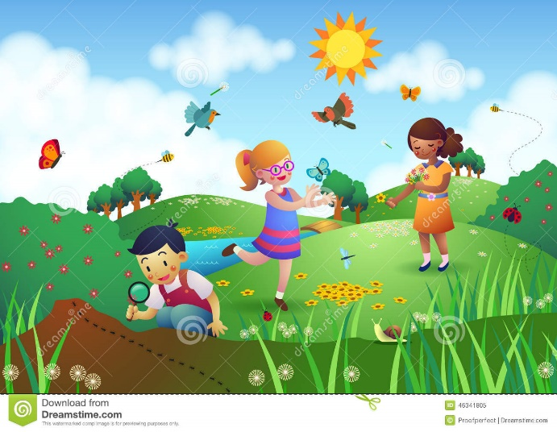

Maths –

* Explore 2D and 3D shapes
* Count up to and beyond 20
* Confidently combining numbers for addition and understanding the processes
* Confidently understand the process of subtraction.

Understanding the World –

* Observe seasonal changes and what happens outside.
* Understanding the life cycle of a beanstalk and other plants.
* Labelling parts of plants
* Compare animals in the UK and Africa.
* Completing experiments while growing cress – what environment do the seeds need to grow?
* Explore the word God and why it is important for Christians.

Expressive Arts and Design –

* Join in with role play games and use resources available for props; build models using construction equipment.
* Learn how to weave to create prints from natural materials.
* Explore paints and paint mixing – primary and secondary colours.
* Perform songs and rhymes on our stage

Come Outside