 | Pensilva Primary School |  |  | Newsletter  1st March 2024
 | Working Together To Make A Difference
 | To Live | To Love | To Learn

Pupils Of The Week

Wrens – Arlo
For being brave coming into school each day

Doves – Max
for his fantastic descriptive story opening

Puffins – Alice
For being a great role model

Headteacher Award – Jacob
For his positive contributions to maths and history lessons

Online Forms
Recently we upgraded our ICT systems. Following this upgrade we are moving to using online forms instead of paper copies. This is designed to make completing the forms easier and prevent letters getting lost in book bags!

Since trialing this with girls football and dance club, we have had positive feedback from parents.

Parent Survey
A reminder that our parent survey is live. This is an opportunity to put forward your views, particularly with regards to our before and after school club provision.
The survey can be found by following this link or be scanning the QR code. We look forward to receiving your views.

SongFest
On Wednesday, our choir club travelled to Launceston Town Hall for SongFest. This concert saw 8 local schools coming together to perform together as one. The theme this year was Sea Shanties.
All 11 children performed brilliantly and represented the school fantastically. The weeks of hard work paid off. A special mention goes to Alfie who was selected just before the performance to perform a solo part!
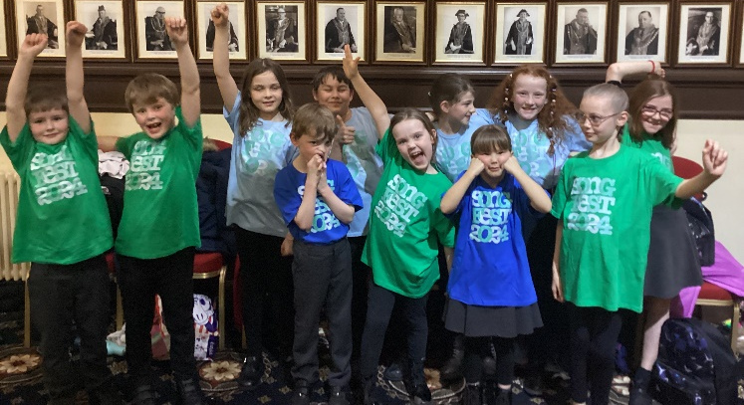
Well done to the children involved and also a huge thank you to Mrs Noblett who gave up her time to run choir club and accompany the children on Wednesday evening. .
Club News
Homework, choir and board games clubs will finish the week beginning Monday 18th March.
Our new dance club will run on Thursday 7th, 14th and 21st March. Thank you to all who signed up – the club is now full. Watch this space for details of the next dance club. If you did miss out, Lily also runs classes in Liskeard. See the attached flyer for details.
World Book Day 2024 Reminder
Pensilva Primary School will be celebrating World Book Day on Wednesday 6th March 2024. This year, parents and carers are invited into classes at 2.45pm on the 6 of March so the children can share their love of reading during the day. The children will have chosen books, poems etc. to share with you, and you are welcome to bring in your own favourite childhood book to share with your child or children.
Children are welcome to wear their uniform on the day or come to school dressed as their favourite book character, but dressing up is not a requirement as we appreciate the financial struggles for many of our families at this time.
As always children will bring home at £1 book token. These can be exchanged for a special World Book Day book or be used to receive a £1 discount on any book. Many local retailers have a selection of the World Book Day books in stock, including The Book Shop, Liskeard.
We're very much looking forward to celebrating World Book Day, and we hope you are able to join us at 2.45pm on 6 of March.
DATE | ACTIVITY | TIME | Notes
07.03.24 | Girls football match vs Dobwalls | 3.45pm | Home match as part of the East Cornwall league.
11.03.24 | Girls football march vs Sir Robert Geffrey’s | 3.45pm | Home match as part of the East Cornwall league.
14.03.24 | Buzzard’s Life Skills Session | 12.30pm | Life skills session hosted by Liskeard Fire Station
15.03.24 | Landrake fun run | 1.30pm | Sir Robert Jeffrey’s School. Leave school at 12.15pm
22.03.24 | Non-school uniform |  | £1 voluntary donation to the PSA
27.03.24 | Whole School Easter Performance | 2.00pm start | Millennium House
28.03.24 | INSET Day | All day | School closed to children
15.04.24 | Return to school after Easter break

A Writing Superstar
Earlier today, Freya from Wrens Class knocked on the office door. She had come to show me her amazing writing about the seed that she planted this week. It’s incredible to think that it is less than 6 months since Wrens started school. The progress is amazing. Take a look at Freya’s writing below.

Bodmin Junior Parkrun
Cross-country club has now finished for the year – but it will be back next year! In the meantime, if anyone is keen to continue their running, why not try Bodmin Junior Parkrun.
This is a free, fun, and friendly weekly 2k event for juniors (4 to 14 year olds). The event takes place at Hillside Park, Scarlett’s Well Road, Bodmin, PL31 2PY. The aim is to have fun. Please come along and join in whatever your pace!
You may even recognize one of the regular volunteer marshals! For more details see: home | Bodmin junior parkrun | Bodmin junior parkrun
Other local junior parkruns take place at Par Athletics Track and at Devonport Park.
St Piran’s Day
A reminder that we will be having a St Piran’ Day menu on Tuesday. Please order your pasty lunch via Aspens Select as usual. Thank you.
Online Safety Newsletter
Please see the attached Online Safety Newsletter. As always there is plenty of up-to-date information and handy hints for parents. This month, there is informatin about managing screen time, managing your child’s device, instagram and more.

PSA News
Thank you to the PSA who ran their first after-school tuck shop yesterday. Judging by the queue of smiling childrne, it was a success. Thank you for organzing.

The PSA have also organize a jumble sale on Saturday 13th April. Details can be found below.

