Pensilva Handwriting Progression Document

Refer also to the Handwriting and Presentation Assessment Documents A to I

EYFS

EYFS Assessment Statements: Letter formation
Most children should be able to:

ELG: Gross Motor Skills:
- Negotiate space and obstacles safely, with consideration for themselves and others;
- Use core muscle strength to achieve a good posture when sitting at a table.

ELG: Fine Motor Skills
- Hold a pencil effectively in preparation for fluent writing – using the tripod grip in almost all cases;
- Develop the foundations of a handwriting style which is fast, accurate and efficient.

ELG: Writing
- Write recognisable letters, most of which are correctly formed;
- [Begin to form lower case letters in the correct direction, starting and finishing in the right place using the RWI rhymes for letter formation]

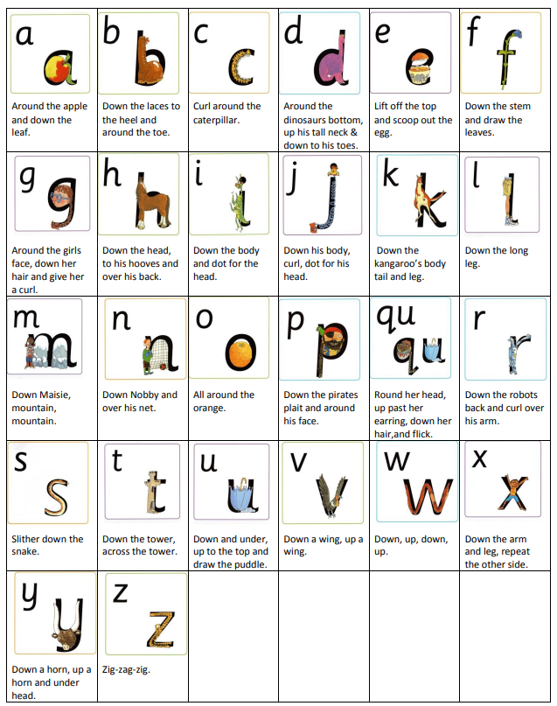
Suggested teaching order in Handwriting and Presentation documents

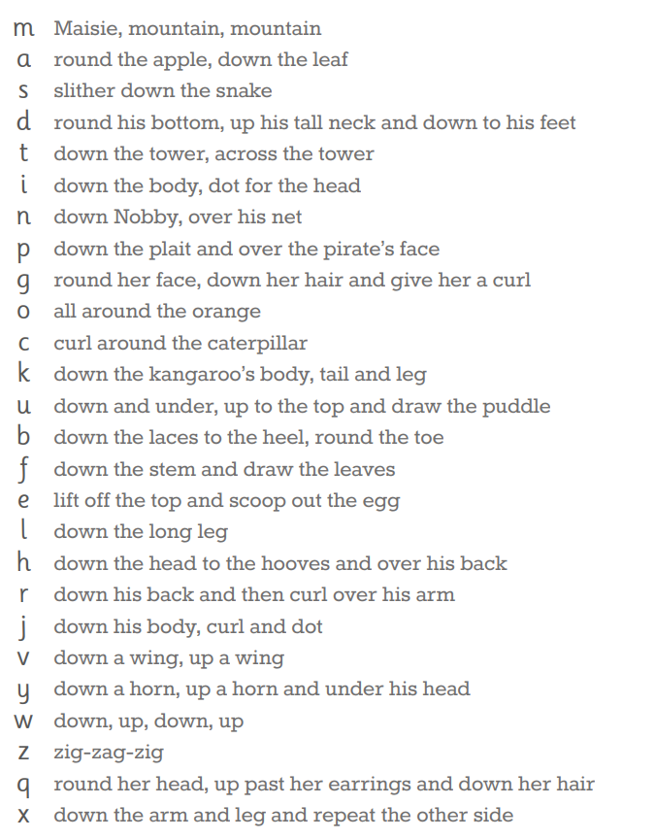

Years 1-6

Year 1 Assessment Statements: Letter formation accuracy and transitioning to pre-cursive
Most children should be able to:
- understand which letters belong to which handwriting ‘families’ (letters that are formed in similar ways) and to practise these.
- Sit correctly at a table and hold a pencil correctly and comfortably.
- To form lower-case letters in the correct direction, starting and finishing in the right place [adding lead ins and lead outs to move to a pre-cursive style]
- Form capital letters.
- Form digits 0-9.

 | Week 1 | Week 2 | Week 3 | Week 4 | Week 5 | Week 6 | Week 7 | Week 8 | Week 9 | Week 10 | Week 11 | Week 12
Autumn | Assess and Target Setting | Straight Letter Family: Form correctly with lead ins and lead outs  (l, i, u, t, y and j) |  |  |  |  |  | The One-Armed Robot Family: Form correctly with lead ins and lead outs  (n, m and h) |  |  | Handwriting Practice | Assess and Review
Spring | The One-Armed Robot Family: Form correctly with lead ins and lead outs  (k, b, p and r) |  |  |  |  | The Curly Letter Family: Form correctly with lead ins and lead outs (c, a, d, e, s and g) |  |  |  |  | Handwriting Practice | Assess and Review
Summer | The Curly Letter Family: Form correctly with lead ins and lead outs  (f, q and o) |  |  | The Zigzag Letter Family: Form correctly with lead ins and lead outs  (z, v, w and x) |  |  |  | Handwriting  Practice: Capital letters and numbers |  |  |  | Assess and Review

Year 2 Assessment Statements: Positioning and Sizing of Letters / Pre-cursive consistency and transitioning to continuous cursive style

By the end of these lessons, most children should be able to:
- form lower case letters with lead ins and lead outs of the correct size relative to one another;
- use spacing between words that reflects the size of the letters.
- Use some of the diagonal and horizontal strokes needed to join letters.
- Begin to join letters.
- Write capital letters and digits of consistent size.

 | Week 1 | Week 2 | Week 3 | Week 4 | Week 5 | Week 6 | Week 7 | Week 8 | Week 9 | Week 10 | Week 11 | Week 12
Autumn | Assess and Target Setting | Straight Letter Family [Upper and Lower case: l, i, u, t, y and j]  Introduce joins (along the line for example at, ai, au, aw, ay, ch, ck, er, ew, ff, ir, kn, ll, qu, sh) |  |  |  |  |  | The One-Armed Robot Family  [Upper and Lower case: n, m and h]  Introduce joins (diagonally upwards, for example ea, as, ed, igh, ing, ng, squ, ss’, ee) |  |  | Handwriting Practice | Assess and Review
Spring | The One-Armed Robot Family  [Upper and Lower case: k, b, p and r] |  |  |  |  | The Curly Letter Family [Upper and Lower case: c, a, d, e, s and g]  Introduce joins (diagonally up to a tall letter, for example el, et, he, te, le, it,) |  |  |  |  | Handwriting Practice | Assess and Review
Summer | The Curly Letter Family  [Upper and Lower case: f, q and o]  Introduce joins (horizontally, for example oa, oh, or, oi, on, ou, ow, oo, op, ov) |  |  | The Zigzag Letter Family  [Upper and Lower case: z, v, w and x] |  |  |  | Focus on the four joins:  - along the line for example ‘a’ to ‘t’  - horizontally, for example ‘o’ to ‘a’  - diagonally upwards, for example ‘e’ to ‘a’  - diagonally up to a tall letter, for example ‘e’ to ‘l’ |  |  |  | Assess and Review

Year 3 and Year 4 Assessment Statements: Positioning and Sizing of Letters / Use of Continuous Cursive to Join

Most children should be able to:
• use the diagonal and horizontal strokes that are needed to join letters
• increase the legibility, consistency and quality of their handwriting by ensuring that the downstrokes of letters are parallel
and equidistant
- increase the legibility, consistency and quality of their handwriting.
- Space lines of writing sufficiently so that the ascenders and descenders of letters do not touch.

Adapt Coverage below as appropriate to meet needs of class as identified in assessment:

 | Week 1 | Week 2 | Week 3 | Week 4 | Week 5 | Week 6 | Week 7 | Week 8 | Week 9 | Week 10 | Week 11 | Week 12
Autumn | Assess and Target Setting | Straight Letter Family [Upper and Lower case: l, i, u, t, y and j]  Revisit joins (along the line for example at, ai, au, aw, ay, ch, ck, er, ew, ff, ir, kn, ll, qu, sh) |  |  |  |  |  | The One-Armed Robot Family  [Upper and Lower case: n, m and h]  Revisit joins Introduce joins (diagonally upwards, for example ea, as, ed, igh, ing, ng, squ, ss’, ee) |  |  | Handwriting Practice | Assess and Review
Spring | The One-Armed Robot Family  [Upper and Lower case: k, b, p and r] |  |  |  |  | The Curly Letter Family [Upper and Lower case: c, a, d, e, s and g]  Revisit joins (diagonally up to a tall letter, for example el, et, he, te, le, it,) |  |  |  |  | Handwriting Practice | Assess and Review
Summer | The Curly Letter Family  [Upper and Lower case: f, q and o]  Revisit joins (horizontally, for example oa, oh, or, oi, on, ou, ow, oo, op, ov) |  |  | The Zigzag Letter Family  [Upper and Lower case: z, v, w and x] |  |  |  | Focus on the four joins:  - along the line for example ‘a’ to ‘t’  - horizontally, for example ‘o’ to ‘a’  - diagonally upwards, for example ‘e’ to ‘a’  - diagonally up to a tall letter, for example ‘e’ to ‘l’ |  |  |  | Assess and Review
Year 5 and Year 6 Assessment Statements: Fluency, Style and Speed
Most children should be able to:
- Write fluently, joined and legibly with increasing speed.
- To develop own personal style (join/not join specific letters – loops).
- To choose the writing implement that is best suited for a task (e.g. quick notes, letters).

Adapt Coverage below as appropriate to meet needs of class as identified in assessment:

 | Week 1 | Week 2 | Week 3 | Week 4 | Week 5 | Week 6 | Week 7 | Week 8 | Week 9 | Week 10 | Week 11 | Week 12
Autumn | Assess and Target Setting | Straight Letter Family [Upper and Lower case: l, i, u, t, y and j]  Revisit joins (along the line for example at, ai, au, aw, ay, ch, ck, er, ew, ff, ir, kn, ll, qu, sh) |  |  |  |  |  | The One-Armed Robot Family  [Upper and Lower case: n, m and h]  Revisit joins Introduce joins (diagonally upwards, for example ea, as, ed, igh, ing, ng, squ, ss’, ee) |  |  | Handwriting Practice | Assess and Review
Spring | The One-Armed Robot Family  [Upper and Lower case: k, b, p and r] |  |  |  |  | The Curly Letter Family [Upper and Lower case: c, a, d, e, s and g]  Revisit joins (diagonally up to a tall letter, for example el, et, he, te, le, it,) |  |  |  |  | Handwriting Practice | Assess and Review
Summer | The Curly Letter Family  [Upper and Lower case: f, q and o]  Revisit joins (horizontally, for example oa, oh, or, oi, on, ou, ow, oo, op, ov) |  |  | The Zigzag Letter Family  [Upper and Lower case: z, v, w and x] |  |  |  | Focus on the four joins:  - along the line for example ‘a’ to ‘t’  - horizontally, for example ‘o’ to ‘a’  - diagonally upwards, for example ‘e’ to ‘a’  - diagonally up to a tall letter, for example ‘e’ to ‘l’ |  |  |  | Assess and Review

