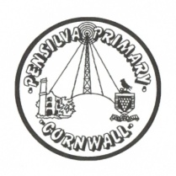
Wren’s Class Home-School Communication Sheet
Week beginning 22nd May
School dinner week 3
This week’s diary |  | Hello Wrens, well done on another excellent week learning all about plants and how they grow. We have also been learning about sharing in maths and have been reading the book ‘Oliver’s Vegetables’.  Please make sure that you are reading your Read Write Inc books that come home. We are so impressed with all the children and how much progress they are making with their reading and writing. This week all the children will also have brought home the set 2 special friends – please encourage them to practise these sounds at home to support their reading and writing.  I have also assigned you some new Mathletics activities to help you practise your maths. – we have been focusing on sharing amounts as well as subtraction and number bonds.  Next week is the last week before half term. After half term we have a couple of inset days – I have written them in upcoming dates below.
Monday | Miss Thomas
Tuesday | Miss Thomas
Wednesday | Miss Thomas
Thursday | Miss King  PE with Mr Jones PM
Friday | Miss King | Upcoming dates:  Monday 29th May – Friday 2nd June – half term.  Friday 9th June – inset day  Monday 5th June inset day.
Other information
Please feel free to send us an email if you have any questions or concerns: Jthomas@pensilva.cornwall.sch.uk lking@pensilva.cornwall.sch.uk
Do not forget the school website; http://pensilva.eschools.co.uk/website for information on school events, policies and newsletters or our Facebook page; Pensilva Primary School for updates.

