Key Instant Recall Facts
Year 2 - Autumn term 2.
I know multiplication and division facts for the 2 and 10 times tables.
By the end of the term your child should know multiplication and division facts for the 2 and 10 times tables.
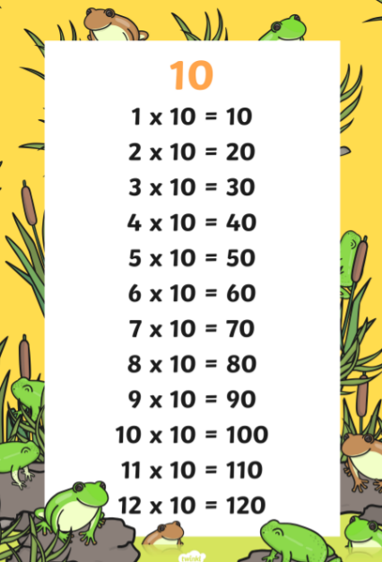
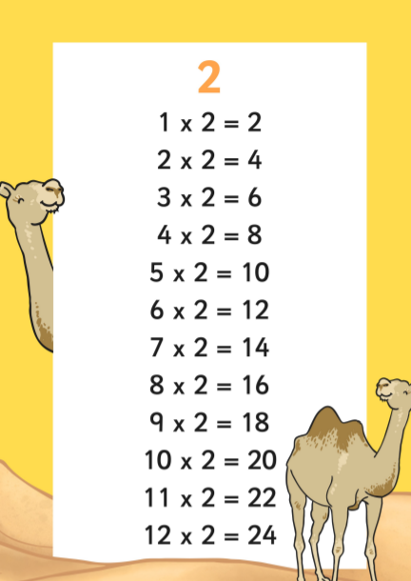
Once your child is confident knowing the multiplication tables they can start to use this to do the divisions – for example “5 x 2 = 10 therefore 10 ÷ 2 = 5”

How you can help at home – remember that a little and often approach is best. Practise the 2 and 10 times tables in the car, on the way home from school, in the bath, waiting in a queue or whenever you have a spare moment.
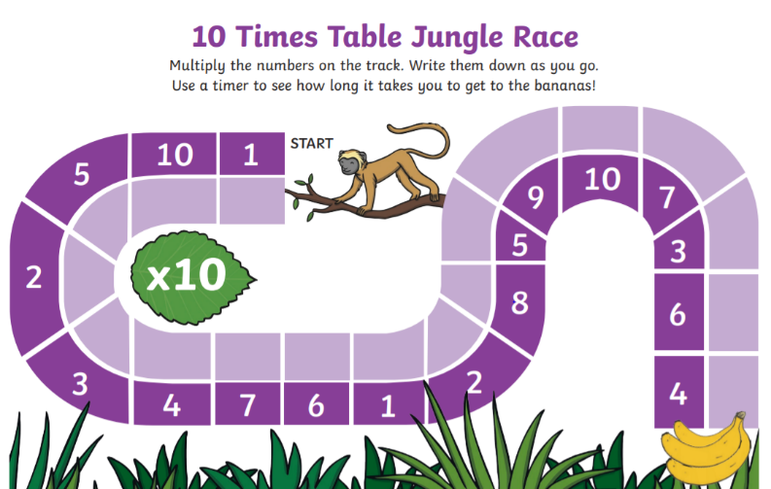
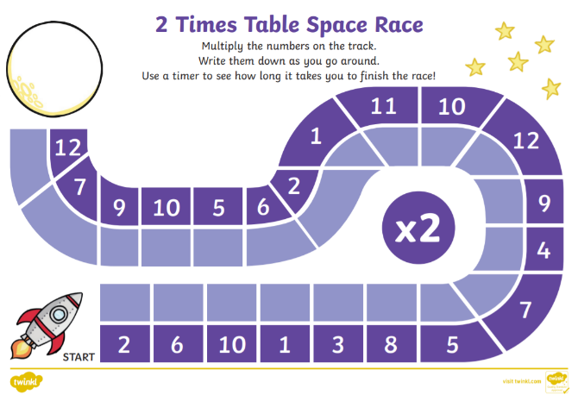
Have a go at solving these times tables races. You can make your own as well to practise.

