Friday 8th January 2021
Warm Up Activity
Multiplying by 2 is the same as doubling numbers.
Eg: 3 x 2 = 6 Double 3 is 6
Practise doubling (multiplying by 2) numbers 1 to 10. Try to learn the answers so that you can double (multiply by 2) quickly any of the numbers, in any order.

Teach
Work through today’s powerpoint with your adult.
Main Task
Complete the following page of activities. It may help to talk through your ideas with your adult.
If you feel confident, you may wish to complete the last page of extension activities too.

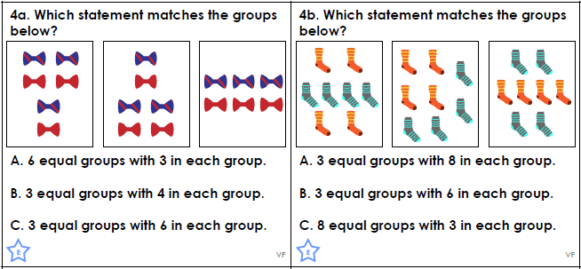
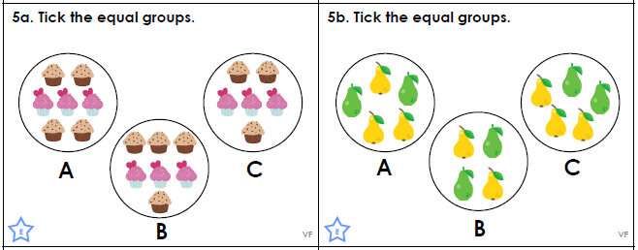
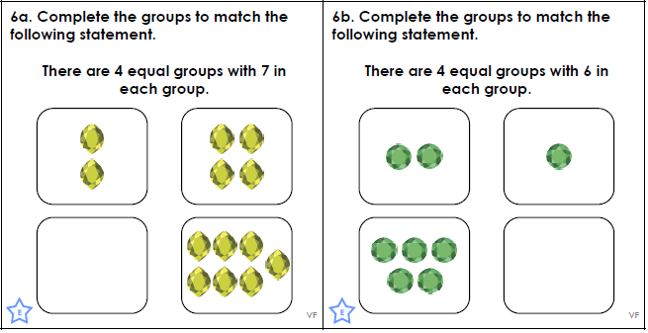

Extension
