 | Pensilva Primary School |  |  | Newsletter  26th April 2024
 | Working Together To Make A Difference
 | To Live | To Love | To Learn
Pupils Of The Week
Wrens – Gracie-Mai
For her focus and improvements in reading and writing.

Puffins – Fin
For settling into his new school and improving the quality and quantity of his work.
Buzzards – Flora
For her musical talents and her determination in all lessons.

Headteacher Award – Joshua
For his focus on determination in Read Write Inc sessions

Clubs
After school clubs begin next week. We have worked hard to provide as many clubs as possible and have tried to ensure that there are clubs for all ages.

We would like to extend our thanks to Mr Marshall, who is a former PE teacher and has volunteered his time to run a basketball club for us.

PSA News
The PSA have organized a Family Bingo evening on Saturday 8th June. Please see the poster opposite for more details.

As always, we are extremely grateful to the PSA for their support. All of the money raised directly benefits the children at school.

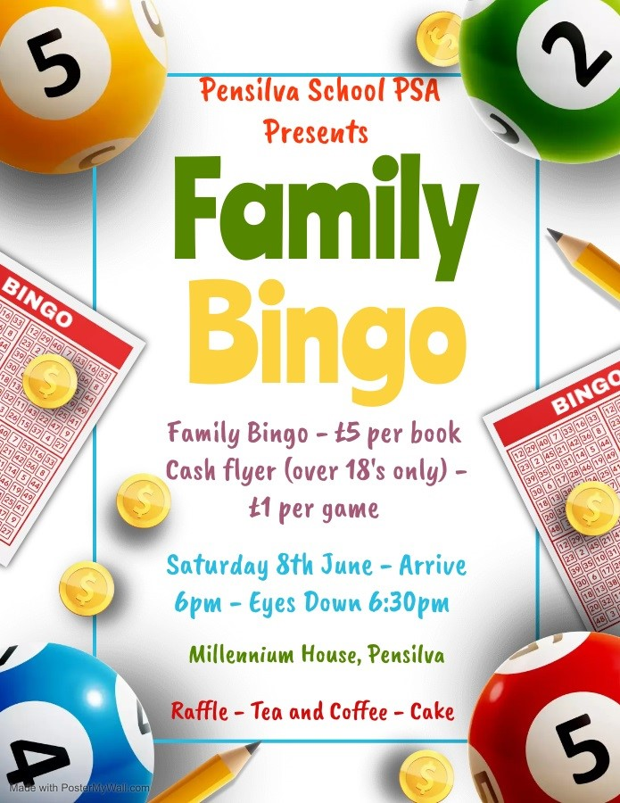

Buzzards lifeskills showcase write

DATE | ACTIVITY |  | TIME | Notes
30.04.24 | Reception Class vision screening |  | 10.00
06.05.24 | Bank Holiday – School Closed
13-16.05.24 | SATs week for Year 6 children
23.05.24 | School Games Dance Afternoon | Afternoon |  |  | Details to follow
27-30.05 | Half term break
06.06.24 | Sports Day |  | TBC | Details to follow
07.06.24 | INSET Day
27-28.05.24 | Puffins Class residential to Eden Project
8-12.07.24 | Buzzards Class residential to Barton Hall
19.07.24 | Summer Fayre | Afternoon |  |  | Full details TBC
24.07.24 | Final day of the academic year.
24.07.24 | Leavers’ Assembly | Time TBC |  |  | Assembly for our Year 6 Leavers
Well done to Grace who wrote a great article for the newsletter on their lifeskills workshop at Liskeard fire station.

