Key Instant Recall Facts
Year 4 - Autumn term 1.
I know all my number bonds to 100
Children can use their number knowledge to help with their number bonds to 100. Here are some examples of number bonds to 100:

Using counting in 10s  10 + 90 = 100  50 + 50 = 100  40 + 60 = 100  30 + 70 = 100 | Using counting in 25, 50 and 75  25 + 75 = 100  75 + 25 = 100  100 – 75 = 25  100 – 25 = 75
100 – 10 = 90  100 – 90 = 10  100 – 50 = 50  100 – 40 = 60  100 – 60 = 40 | Challenge:  91 + 9 = 100  23 + 77 = 100  52 + 48 = 100  85 + 15 = 100

How to help at home: remember little and often is best! Practise these as much as you can but in short 5 minute bursts – maybe on the way to school or on a long car journey.

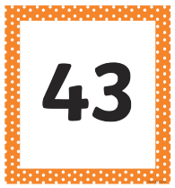
Roll 2 dice or make some number cards. – what do I need to add to the number to make 100?
7 + ____ = 100
See how many you can solve in 3 minutes and then use a calculator to check you answers. Can you beat your parent?
43 + ____ = 100

