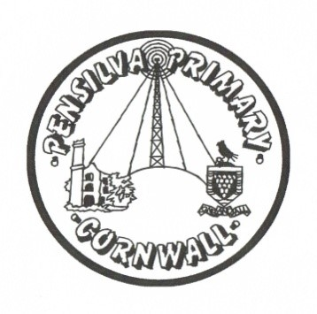

Art & DT Rolling Program
Years A and B 2022/2023 – 2023/2024
Term | Autumn A |  | Spring A |  | Summer A |  | Autumn B |  | Spring B |  | Summer B
 | Art – | DT – | Art – | DT - | Art – | DT – | Art | DT | Art | DT | Art | DT
Buzzards  Y5/6 | Craft and Design: Photo opportunity (Year 6) | Digital world – Navigating the world.  Year 6 | Drawing – make my voice heard (Year 6) | Structure – Playgrounds  Year 6 | Sculpture 3D – Making memories | Textiles – Waistcoats  Year 6 | Painting and Mixed Media: Portraits (Year 5) | Mechanical systems – making a pop-up book.  Year 5 | Sculpture and 3D: Interactive Installation (Year 5) | Food: What could be healthier? | Drawing – I need space | Electrical systems - Doodlers
Puffins  Y3/4 | Drawing Power Prints  Year 4 | Mechanical systems – making a slingshot car.  Year 4 | Painting and mixed median  Light and dark  Year 4 | Structures – Pavilions  Year 4 | Craft and Design: Ancient Egyptian Scrolls Year 3 | Electronical systems – Torches  Year 4 | Drawing Growing Artists  Year 3 | Digital world – electronic charm.  Year 3 | Sculpture and 3D – Abstract shape and space  Year 3 | Food – Eating seasonally Year 3 | Craft and design  Fabrics of nature  Year 4 | Structures – constructing a castle.  Year 3
Doves  Y1/2 | Painting and mixed  media: Beside the  seaside | Structures  Make a chair for a rocket.  Year 2 | Sculpture and 3D  Clay houses  Year 2 | Mechanism – Fairground wheel  Year 2 | Craft and design  Map it out Year 2 | Mechanisms – Making a moving monster.  Year 2 | Drawing  Make your mark Year 1 | Structures  Constructing windmills Year 1 | Painting  Colour splash  Year 1 | Food – Fruit and vegetables  Year 1 | Sculpture and 3D  Paper play  Year 1 | Textile Puppets  Year 1
Wrens | Drawing – Marvellous marks | Cooking and Nutrition - Soup | Painting and mixed media | Textiles – Bookmarks | Sculpture and 3D – creation station | Structures – junk modelling | Drawing – Marvellous marks | Cooking and Nutrition - Soup | Painting and mixed media | Structures – junk modelling | Craft and design – let’s get crafty | Structures -Boats

