Due to Covid should a child/children need to isolate and stay at home, but remain well enough to access learning, we at Pensilva are aiming to provide remote education that mirrors the learning opportunities that they would receive in school.
A child’s first day of being educated remotely will look different from our standard approach, while we take all necessary actions to prepare for a longer period of remote teaching.
What should my child expect for the first day of needing to remain at home?
On Day one of your child not being in school, please use your child’s logins and the internet to access a variety of websites for general work. Below are a range of suitable activities and links with a suggested time for children to be engaged in each subject area.
Maths | 30 – 60 minutes | TT Rockstars (Yr 2 only) / Mathletics / K.I.R.F.S practice  Times tables practise for 2s, 5s, and 10s.
English Writing | 30 – 60 minutes | Choose one writing task from those suggested below this timetable:  - Under the sea – describe what you can see in full sentences.  - Camp fire – answer the questions in full sentences. Remember capital letters, finger spaces and full stops!
English Spelling | 10-15 minutes | Learn to spell or practise using these focus words in interesting sentences:  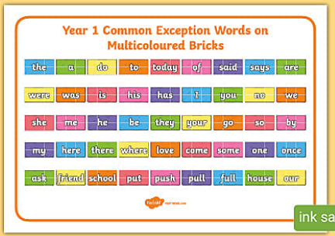  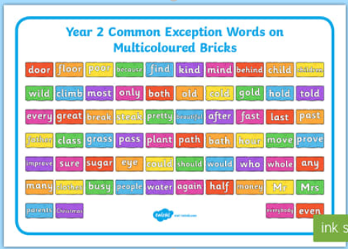
English Reading | 30 – 60 minutes | Read one of your school books or a book from home and then complete one of the response tasks below:  - Write questions that you would like to ask one of the characters from the story you have been reading or that you would like to ask the author  - Create a poster all about your favourite book character and why you have chosen them.  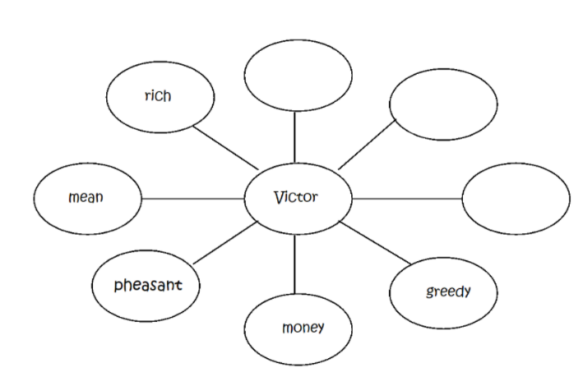  - Create a bubble map of words to describe a character from a story. Write their name in the centre and your chosen words around the outside e.g.
Art & Design | 30 to 60 minutes | Complete a handprint pattern using any materials you like.  https://www.youtube.com/watch?v=eYlPYEQil54
PE | 60 minutes | Incorporate a range of physical activities throughout the day.  Joe Wicks 5 Minute PE sessions on YouTube: https://www.youtube.com/watch?v=d3LPrhI0v-w  Or PE with Joe for a longer session. This is a link to one of the many you will find on You Tube: https://www.youtube.com/watch?v=p8uBfGUEk5c  Cosmic Yoga on YouTube also.

From Day 2, we aim to teach a curriculum that mirrors the school-based curriculum as closely as possible. Therefore, please expect activities for English, mathematics and one other subject to be set each day via Microsoft Teams. Your child’s completed activities should be submitted via Microsoft Teams. If you have any questions regarding this please contact the school via email or the class teacher via either their email or through Teams.
In addition to the daily tasks being set by the class teacher each day, your child needs to:
- Read their school reading book or share a book with an adult
- practise KIRFS (5-10 minutes)
- practise weekly spellings (5 – 10 minutes)
- Keep moving! Aim to be active for an hour a day.

