Wrens Class Medium Term Plan Summer 2

Communication and Language –

* Learn good listening skills
* Show an interest in stories
* Join in with repeated phrases
* Engage in conversation using sentence stems
* Learn new vocabulary to expand explanations

Personal, Social and Emotional Development –

* To share and take turns with friends.
* To manage their own feelings with support
* To manage personal hygiene
* To resolve conflict using sentence stems
* To learn about making healthy choices with foods and exercise
* To understand the importance of oral hygiene

Physical Development –

* Follow Dough Disco for hand strength
* Threading, play dough, loose parts
* To use tripod pencil grip confidently
* Scissor control
* Learn how to hold a knife and fork properly
* Parachute games
* Ball games
* Construction site outside
* Building dens
* Athletic skills for Sports Day

Literacy –

* Read Write Inc Hold sentence activity.
* Explore the following texts Tiddler and information texts about the oceans and the animals that live in them.
* Sequence pictures for the stories we share.
* Participate in Drawing Club to develop imagination and writing.
* Form letters correctly.
* Write simple sentences ensuring finger spaces are used.
* Create story mountains and identify the beginning/middle and ending of familiar stories.

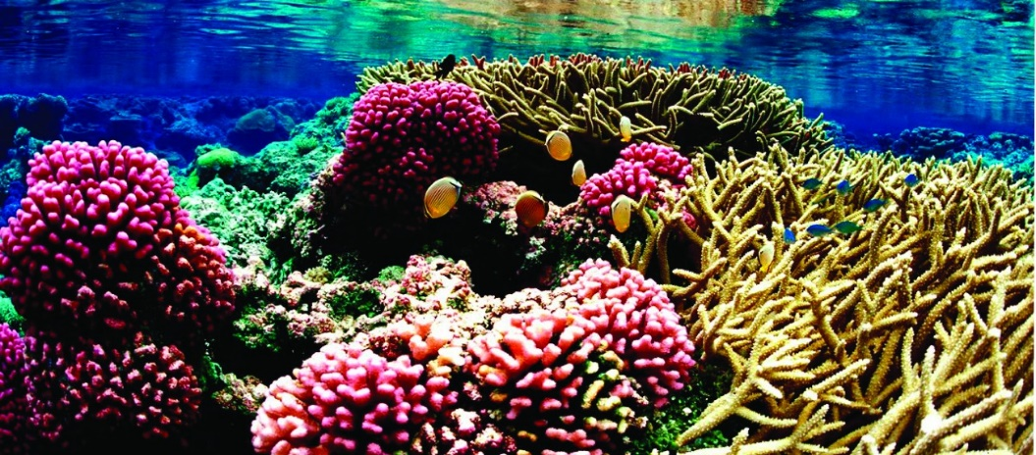

Maths –

* Know number bonds for 5 and 10
* Compare length/weight and mass.
* Confidently complete addition and subtraction sums using a number line.
* Confidently working with numbers 0-10 some moving on to 20.
* Confidently compare length, weight and capacity
* Know how to double and halve numbers to 10

Expressive Arts and Design –

* Joining in with songs and performing on our class stage.
* Join in with role play games and use resources available for props; build models using construction equipment.
* Create and combine materials on the junk modelling table.
* Use clay to create sculptures.

Let’s make a splash!

Understanding the World –

* Observe seasonal changes and what happens outside.
* Investigate underwater creatures and their habitats
* Continue to focus on healthy eating, keeping physically fit and the importance of brushing our teeth.
* Explore the ocean names and where they are on world maps.
* Compare different countries and their shoreline to the UK.