Key Instant Recall Facts
Year 2 - Autumn term 1.
I know addition and subtraction facts to 20.
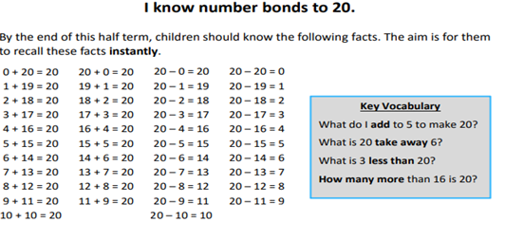

Remember: little and often is better! Can you do a ‘quick fire quiz’ in the car or on the walk home from school? Can you practise for 5 minutes as you are running the bath or waiting for dinner.
Children: test your parents – Can they do these number bonds as quick as you!
Encourage your child to look for patterns using everyday objects.
13 + 7 = 20
20 – 7 = 13
20 – 13 = 7

