Wrens Class Medium Term Plan Spring 2

Communication and Language –
- Learn good listening skills
- Show an interest in stories
- Join in with repeated phrases
- Engage in conversation using sentence stems
- Learn new vocabulary to expand explanations

Personal, Social and Emotional Development –

- To share and take turns with friends.
- To manage their own feelings with support
- To manage personal hygiene
- To resolve conflict using sentence stems
- To learn about making healthy choices with foods and exercise
- To understand the importance of oral hygiene

Physical Development –

- Follow Dough Disco for hand strength
- Threading, play dough, loose parts
- To use tripod pencil grip confidently
- Scissor control
- Learn how to hold a knife and fork properly
- Parachute games
- Ball games
- Construction site outside
- Building dens
- Gymnastic skills in PE
- Forest School

Literacy –
- Read Write Inc Hold sentence activity.
- Explore the following texts Oliver’s Vegetables and All About Plant Parts.
- Sequence pictures for the stories we share.
- Participate in Drawing Club to develop imagination and writing.
- Write their names with accurate letter formation.
- Form letters correctly.
- Begin to write simple sentences.
- Create story mountains and identify the beginning/middle and ending of familiar stories.
- Create diaries for their cress experiments.

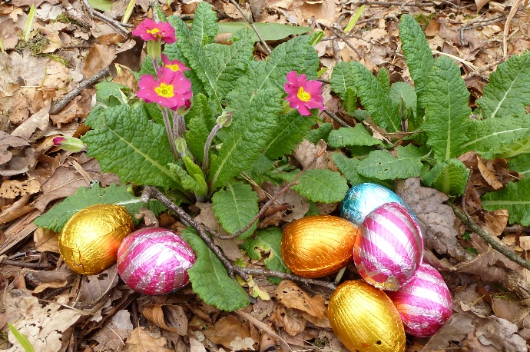
Maths –
- Find one more and one less up to 10
- Compare length/weight and mass.
- Confidently complete addition and subtraction sums with concrete apparatus
- Confidently working with numbers 0-10
- Explore 2D and 3D shapes
- Begin to double and halve numbers to 10

Understanding the World –
- Observe seasonal changes and what happens outside.
- Understanding the life cycle of frogs and other animals.
- Completing experiments while growing cress – what environment do the seeds need to grow?
- Exploring the Easter story and what it means to Christians.
- Planting their own vegetables and tasting different fruits and vegetables linking to the story Oliver’s Vegetables.
- Knowing the names of the different parts of a plant.

Expressive Arts and Design –
- Joining in with songs and performing at our Easter Assembly
- Join in with role play games and use resources available for props; build models using construction equipment.
- Explore the work of Antony Goldsworthy and create our own outdoor sculptures.
- Learn how to weave to create Easter baskets.
- Bake easter cakes/biscuits

Who’s growing outside?

